Noyce MTF Geometry Lesson Study Group
Semester 1 Teaching – Learning Plan
December 9th, 2014

Abstracting angle relationships to solve problems
Research Theme:
To provide a learning experience for students that fosters the internalization of persistence and critical thinking.

Context of lesson (prior and subsequent learning): Before the lesson, frontload Tier I abstraction problems: Linear Pair, Complementary, Angle Bisector, Triangle Sum, Exterior, Isosceles, and Parallel Lines

Relevant CCSS Mathematics Standards:
Solve real-life and mathematical problems involving angle measure, area, surface area and volume.
7.G.B.5: Use facts about supplementary, complementary, vertical and adjacent angles in a multi-step problem to write and solve simple equations for an unknown angle in a figure.

Relevant CCSS Mathematics Practices:
#1 – make sense of problems and preserve in solving them; #2 – reason abstractly and quantitatively

Data Collection Points

Each person takes a quadrant of the room, looking specifically at:

- specific ways mathematical ideas are communicated
- questions asked between students (procedural vs. conceptual)
__________________________________________________________________________________________

Lesson Plan
December 9th, 2013
Mar Vista High School
Classroom of Chip Case

Morse High School
Classroom of Joseph Hyun

Activities | Anticipated Responses (Student/Teacher) | Points to Notice
- (20mins) Level 1 Abstraction  - Joseph’s warm-up problems:  - #1: Ext Angle & Isosceles  - Step by step information  - Solution time  - Discuss Equation  - #2: Tri sum & bisector  - Give Complete Info  - Discuss Equation: Show student examples  - Level 2 Abstraction  - #3: Isosceles & Bisector  - Complete Info  - (10mins) Level 3 PT | #1: “What does this statement tell you about the diagram?”  - Xy=xz  - Isosceles  - Angles Same  - Same Sides  - Wxz=147  - Exterior angle  - Linear Pair  - Solve  - With or without algebra  Did you use a variable? Did you write an equation? Could you do so now?  #2: “Read each statement, discuss what it means, and then solve the problem.”  - No response/give up  - Not knowing how to use a bisector. Definition not leading to practice.  - Where can you put x?  Did you use a variable? Did you write an equation? Could you do so now?  #3: “Read each statement, discuss what it means, define a variable, and then solve the problem.”  - Incorrect placement of variable  - Multiple x, not the same  - Different representations of x  - Avoid abstraction  - False assumptions | #1  - Language/Vocab  - Specific Angles, which 2?  - Content Specificity  - Notation  - Measurement in the correct place?  - Ability to mark a diagram  - Methods of solving: Alg/Numberic  #2  - Quality of explanations of meaning.  - Expand on given info?  - False assumptions  - Who used and equation? Who did not?  - Exemplary student work  #3  - Use of variable  - Ability to set up an equation  - Different strategies for solving.

Corresponding problems:

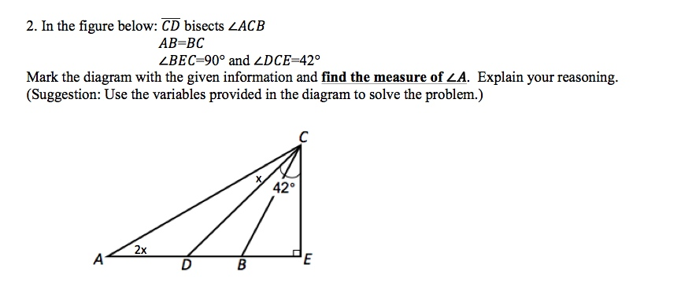

Data Collection Points

Each person takes a quadrant of the room, looking specifically at:

- mathematical vocabulary use by students
- specific ways mathematical ideas are communicated
- questions asked between students (procedural vs. conceptual)
- success rate of abstraction & improvement

